Marcus Villena

6530661

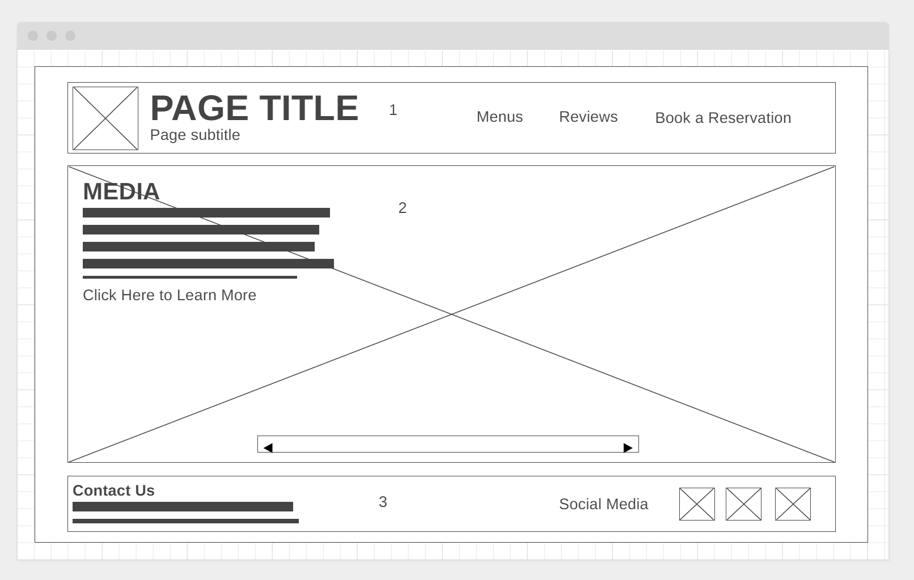  
<https://wireframe.cc/JhV4FL>

**Item 1**

Description: Header: Restaurant Title/Subtitle & Main Navigation

Font: Segoe UI 32 px

Color: White

Background: Black

Alignment: Left

Media: Restaurant Logo

Interactivity: Navigation Links (Menu, Reviews, Reservation)

**Item 2**

Description: Media & Main Content

Font: Segoe UI 24 px

Color: Black

Media: Restaurant Media (e.g. Oktoberfest 2012, Live Music, etc.)

Alignment: Left

Interactivity: Image/Media Carousel, click to navigate to next media

**Item 3**

Description: Footer: Contact Information and Social Media

Font: Segoe UI 24 px

Color: White

Background: Black

Alignment: Left

Media: Social icons for social media platforms

Interactivity: Navigation links to social media platforms